Two Bookkeepers and a Clay Floor
How EPA SWMM 5.2.4 credits decompacted topsoil over compacted clay. Robert Dickinson, SWMM Enablement, October 2026.
A stormwater credit for soil restoration has one job. It has to say how much of a one-inch storm a field of tilled, composted topsoil will swallow in March. Not in July. In March, when the trees are bare and the ground has been wet since Thanksgiving.
Four inches of good topsoil at 50 percent porosity holds two inches of pore space. Drain it to field capacity and you get 0.8 inch of room back. Dry it to the wilting point and you get 1.4. Under it sits compacted sandy clay that passes water at about a hundredth of an inch an hour, which is 0.24 inch a day. Those three numbers are the whole problem. Everything else is bookkeeping.
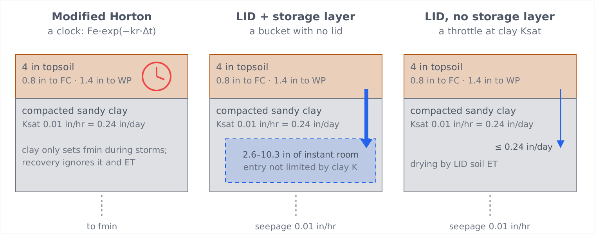
Figure 1. The same profile as three SWMM 5.2.4 setups see it.

The first bookkeeper keeps a clock
Modified Horton keeps one number: the water it has let in above the minimum rate. It forgives that debt on a schedule. Every dry time step, the debt is multiplied by a decay factor set by the drying time you typed.
Fe ← Fe · exp(−kr · Δt), kr = −ln(0.02) / DryTime × RECOVERY(month)
With a seven-day drying time, the debt is 43 percent repaid after one day, 81 percent after three, and 98 percent after seven. That is a clock. It never asks whether the sun is out or whether the clay below can take the water. Make the clay impermeable and the clock keeps running. In the January test it still caught 78 percent of a one-inch storm after a week, with nowhere for the water to go. The only dial that ties it to the season is the monthly RECOVERY pattern. Scale that to evapotranspiration and the dormant-season capture of big storms falls from 77 to 47 percent.

The second bookkeeper owns a bucket with no lid
The LID setup puts the topsoil in the soil layer and the compacted clay in the storage layer. These books are real: topsoil moisture, storage depth, ET by month. The blind spot is in one line of code. The topsoil drains at its own unsaturated conductivity, capped only by the empty room left in the storage layer. The clay's ability to accept that water never enters the calculation.
//... limit soil perc by unused storage volume
maxRate = StorageExfil + StorageDrain + StorageEvap +
(storageThickness - storageDepth) * storageVoidFrac/Tstep;
SoilPerc = MIN(SoilPerc, maxRate);
Give that bucket 24 inches of sandy clay. Enter the void ratio from drainable porosity and the bucket has 2.6 inches of instant room; enter it from total porosity and it has 10. It empties at the seepage rate, 0.24 inch a day, which is faster than four inches of rain a month can fill it. So it never fills. Every storm, in both seasons, was captured in full. With the clay made impermeable, the growing season was still captured in full.

What the clay will actually take
Green-Ampt answers that from the clay's own numbers: Ksat 0.01 in/hr, suction 9.45 in, and 0.109 of drainable pore space. Make the most generous assumption, with water standing on the clay from the first minute of the storm.
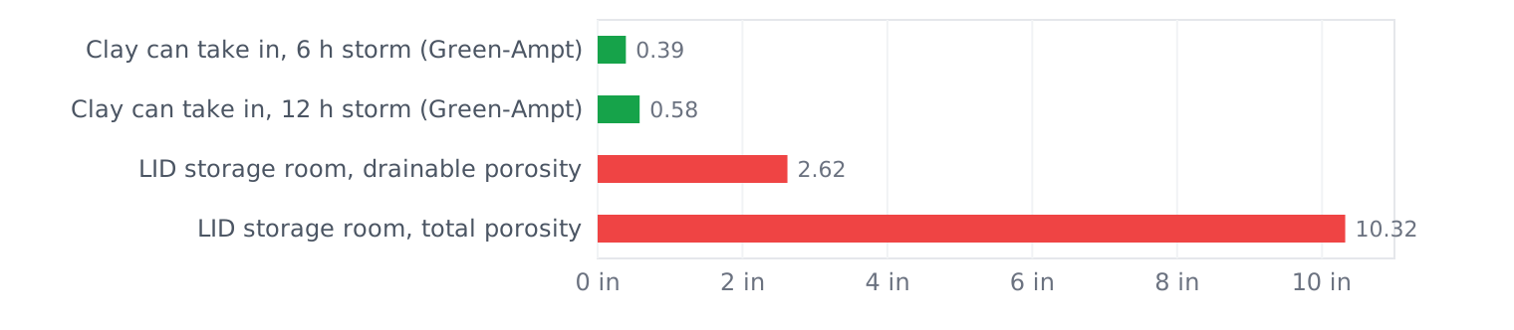
Figure 2. The most the clay can take in during a storm, compared with the room the LID storage layer offers the moment the storm starts.
Six hours allows 0.39 inch. Twelve hours allows 0.58. The bucket offers two to twenty-six times that, and it offers it instantly.

The throttle that is already in the code
A third arrangement is already in 5.2.4, and it is the most honest of the three. Leave the storage layer out and put the clay's Ksat in the seepage field. SWMM then holds topsoil drainage to that seepage rate. The clay throttles drainage, ET does the drying, and the season appears without any tuning. This setup caught 79 percent of big storms in winter and 95 in summer. Make the clay five times tighter and winter drops to 54 percent while summer barely moves. That is how a credit ought to behave.
It is still not a perched water table. Field capacity acts as a floor. Nothing pulls water into the clay by suction, no water table rises inside the topsoil, and nothing drains sideways. If field data show the topsoil sitting wetter than field capacity all winter, this setup still gives back too much. A perched-zone option in SWMM would close that gap.

The numbers
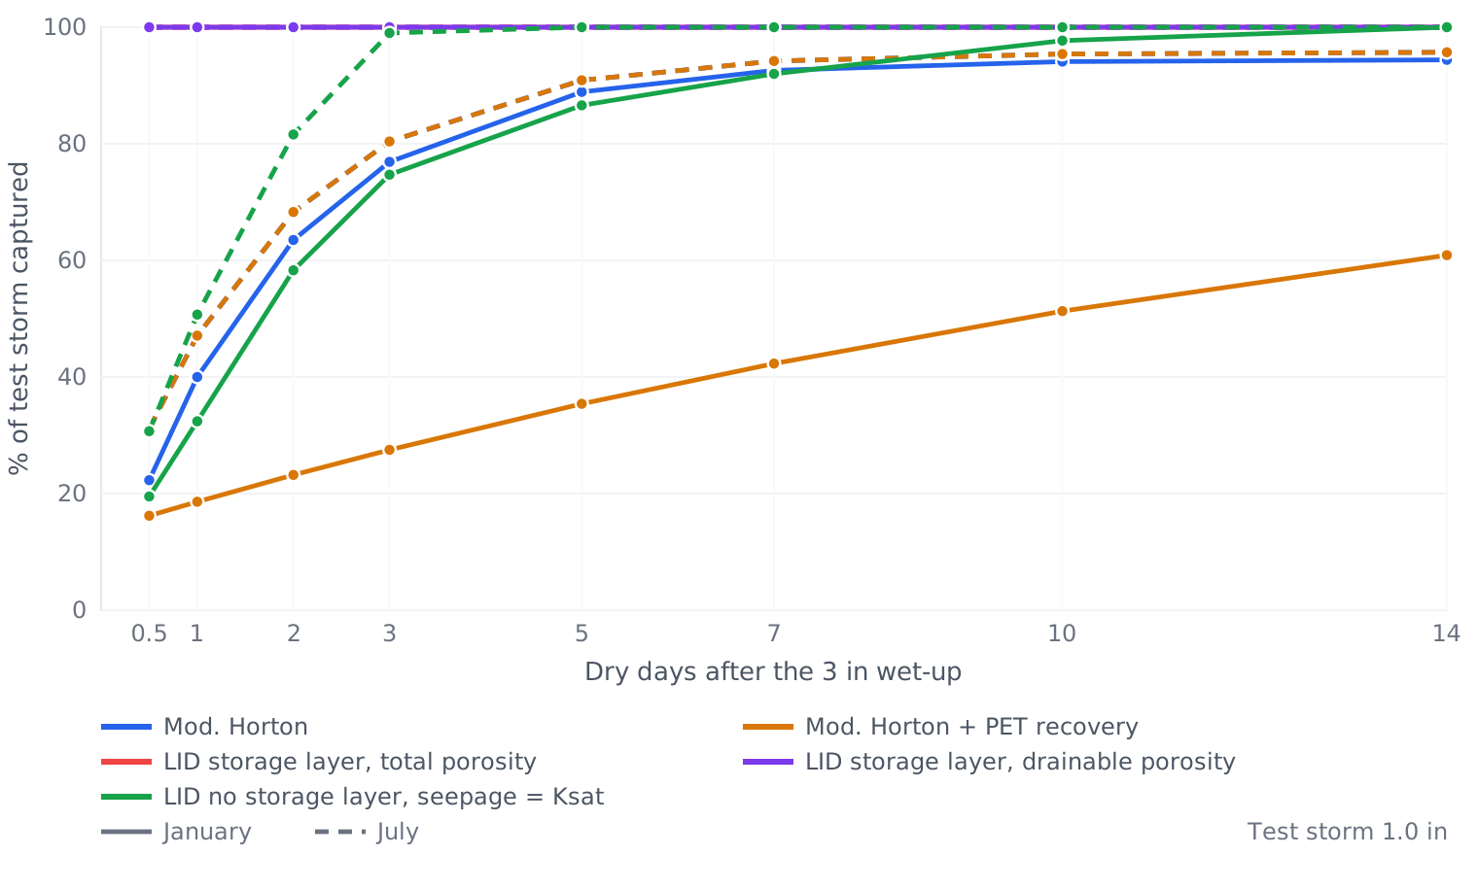
Figure 3. Share of a 1.0 in test storm captured after D dry days, following a 3 in wet-up. Solid lines are January; dashed lines are July. The two LID storage-layer lines lie on top of each other at 100 %.
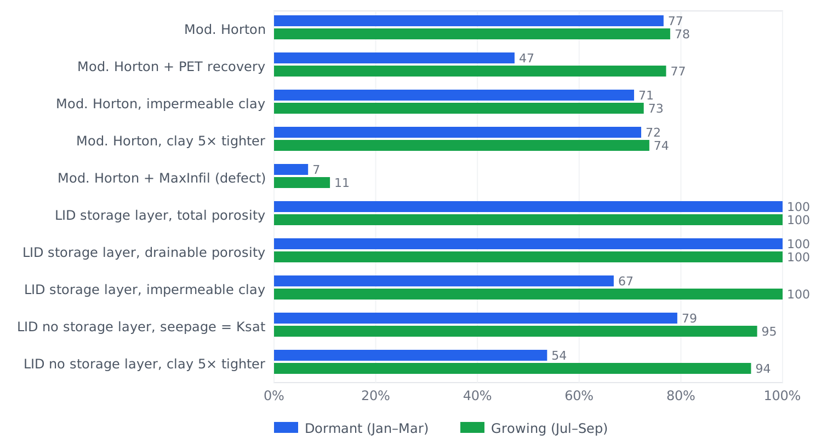
Figure 4. Share of storms of 0.75 in and larger captured over a synthetic 90-day dormant season and growing season, with storms every 6 days at about 4 in/month.

A second objection: soil is not pea gravel
The soil scientist who raised the question added a deeper point. Filter sand has only textural porosity: the gaps left by how the grains pack, and that porosity barely changes. Soil has a second kind. Its large, connected macropores come from the packing of aggregates, crumbs of sand, silt and clay held together by organic matter, roots, fungi and soil fauna. Nimmo (2004) calls this structural porosity. It carries most of the infiltration, and the soil ecosystem has to keep rebuilding it.
Two consequences follow. Compaction destroys the macropores first, so the first increment of compaction cuts Ksat far more than the change in bulk density suggests. And when saturation lasts longer or comes more often, as it does in a perched zone over compacted subsoil, the aggregates break down and the structural porosity goes with them. Leij, Ghezzehei and Or (2002) model the pore-size distribution after tillage as something that changes with time, not a fixed property.
His HYDRUS runs cover a full year of 1 m moisture profiles for two cases: an undisturbed soil at native bulk density with 5 % organic matter, and a topsoiled profile with 10 cm of uncompacted soil at 3 % organic matter over 90 cm compacted to a 10 % higher bulk density. In the topsoiled profile the top 10 cm returns to saturation again and again, with hard drying spells in the growing season, while the compaction below cuts percolation sharply. Those are the conditions that break aggregates down.
The same question can be put to SWMM: for how many hours in the 90-day window was the 4 in topsoil within 0.01 of saturation?
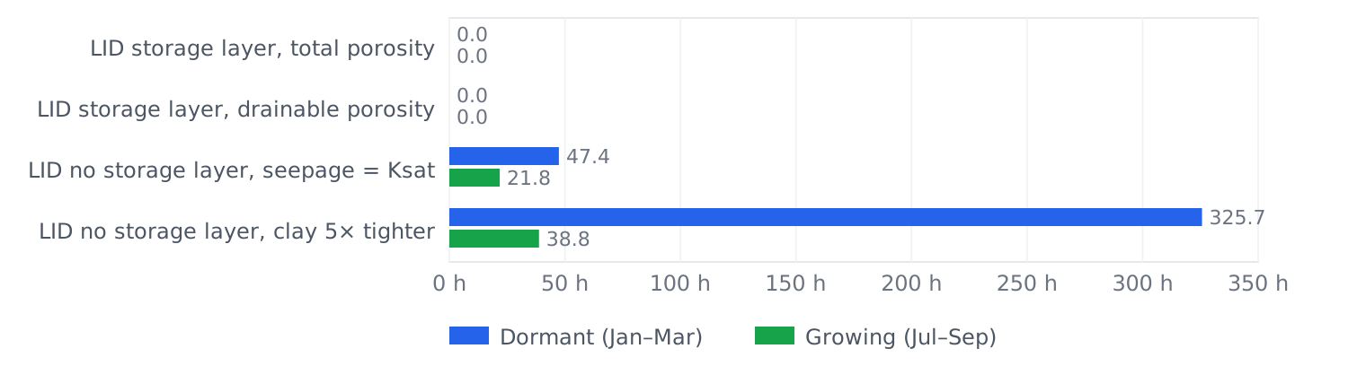
Figure 5. Hours with topsoil moisture at or above 0.49 (porosity 0.50) in the 90-day scoring window, read from the LID report file at the 1-minute wet step.
The storage-layer setups never let the topsoil saturate, because the bucket below swallows every storm. The throttle setup saturates it for 47 hours in winter, in spells of up to 15 hours. Make the clay five times tighter and that becomes 326 hours, 15 percent of the season, in spells of up to 40 hours. That is the perched regime his HYDRUS runs show.
Every setup keeps porosity, field capacity and Ksat at their day-one values for the whole run. Nothing in SWMM 5.2.4 lets a tilled layer lose structure after weeks of saturation. A perched-zone option with fixed van Genuchten parameters would get the water budget right and still credit the tilled layer with its day-one structure forever. A credit for shallow tillage has to answer two questions: whether the storage recovers between storms, and whether the pores that provide it last.

A fourth bookkeeper: the perched engine
The fix for the bucket is one rule: the clay decides how fast it drinks. swmm524-perched is EPA SWMM 5.2.4 with a SOIL2 line for the compacted layer under a bio-retention cell. Each time step, SWMM's own Green-Ampt routine works out the most water SOIL2 can take in, with the perched water depth in the topsoil added to the suction head. Topsoil percolation cannot exceed that capacity. Whatever the clay refuses stays in the topsoil, which saturates from the bottom up. SOIL2 drains to native soil at its own K(θ), capped by the seepage rate. An optional STRUCT line lets the topsoil Ksat decay while saturated and recover once it drains to field capacity.
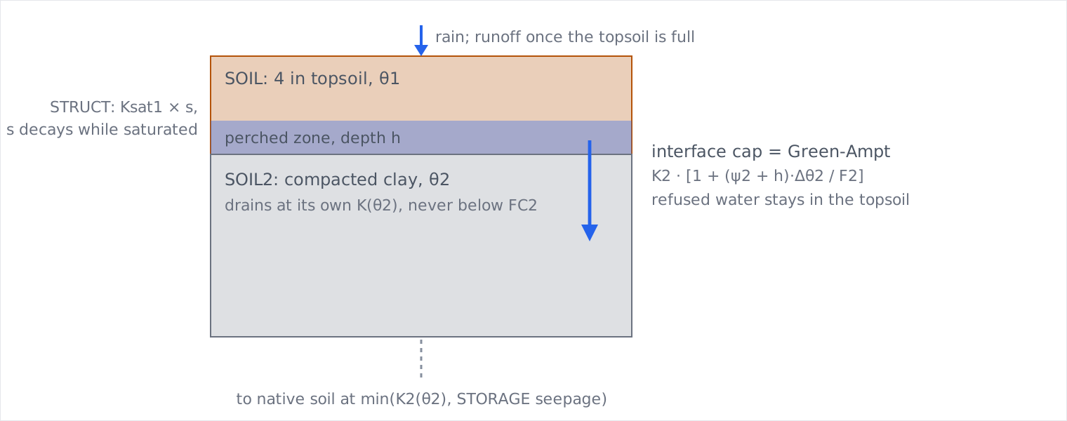
Figure 6. The perched option in swmm524-perched.
Controls: with the option off, the engine wrote byte-identical .out files to EPA 5.2.4 on all 598 study inputs. With SOIL2 conductivity pushed to 1000 in/hr and no suction, it reproduced the stock storage-layer bucket to 0.000 in on all 64 recovery cases. STRUCT 0 0 1 matched no STRUCT line byte for byte. Runoff continuity stayed within 0.003 %.
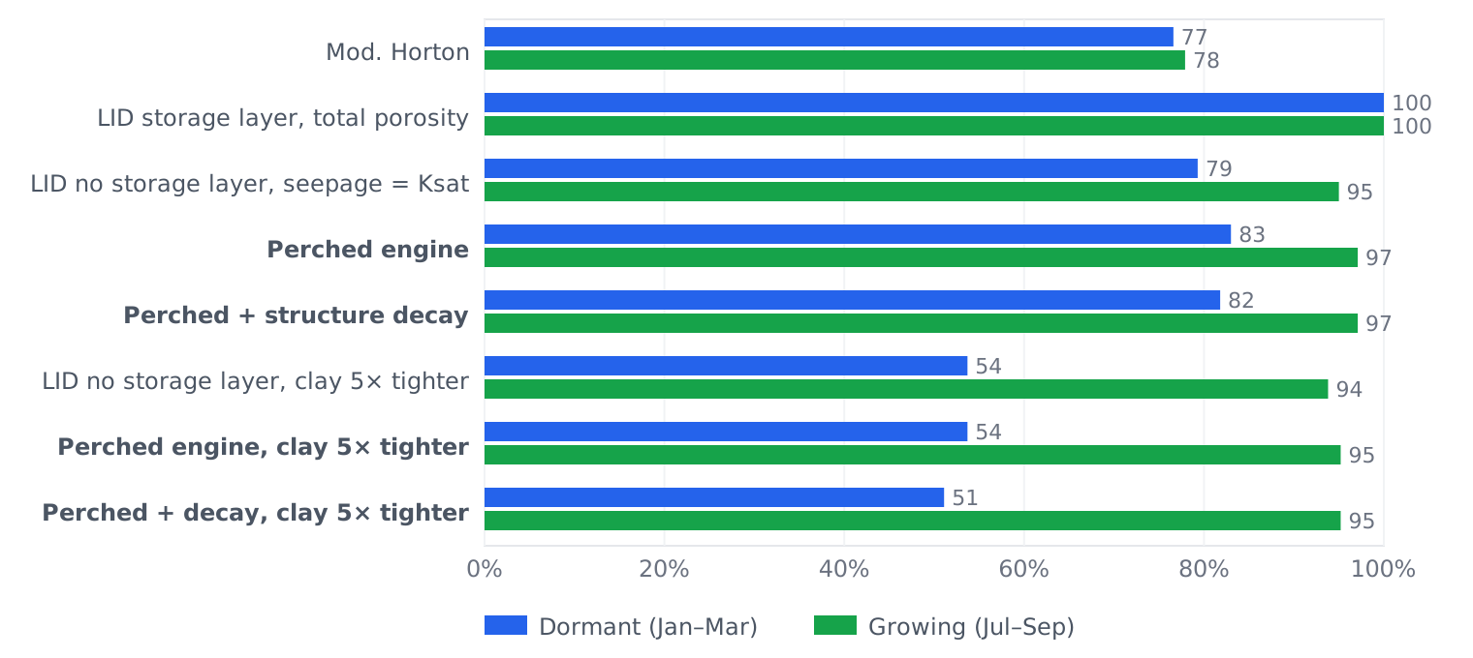
Figure 7. Storms of 0.75 in and larger captured over the synthetic dormant and growing seasons, perched engine against the stock setups.
The perched engine captures 83 percent of big storms in winter and 97 in summer, and the season comes out of the physics with no tuning. In winter the compacted layer averages 0.41 moisture against 0.43 porosity, so the interface runs at about the clay's Ksat. With the clay five times tighter, winter capture falls to 54 percent and the topsoil sits saturated for 326 hours. Once the clay stays wet, the stock no-storage-layer throttle gives nearly the same answer. The new engine matters when the subsoil has room to absorb water. Structure decay moves the tight-clay case only from 54 to 51 percent, because the clay sets the rate and only Ksat, not macropore volume, degrades in this version. The engine has not yet been compared with HYDRUS. Source: github.com/SWMMBobSWMM6/swmm524-perched.

One broken knob, found on the way
Modified Horton has an optional cap called MaxInfil. In 5.2.4 the line that applies the cap says MAX where it means MIN (infil.c, line 545). On the first wet step the running total jumps straight to the cap, and every step after that returns zero. With MaxInfil set to 0.8 inch, a four-inch rain infiltrated 0.002 inch. Anyone using that cap with this build is getting far too much runoff, not too little.
if ( infil->Fmax > 0.0 ) infil->Fe = MAX(infil->Fe, infil->Fmax);

What this does not show
None of this is calibrated to a real site, and none of it stands in for a HYDRUS profile or a monitored plot. The rain is a synthetic storm train. There is one site and one soil pair: 4 in of topsoil with porosity 0.50, FC 0.30, WP 0.15 and Ksat 1.0 in/hr, over 24 in of compacted sandy clay using the Rawls values with Ksat halved to 0.01 in/hr. The Horton f0 (3 in/hr) and drying time (7 days) are typical choices, not calibrated ones. What the runs do show, in the engine's own numbers, is which knob moves which answer.
Controls: a RECOVERY pattern of all 1.0 matched the run without one in 66 of 66 .out pairs, byte for byte. Repeat runs were byte-identical. Runoff integrated from the .out files matched the .rpt totals within 0.033 in. The worst runoff continuity error was 0.017 %. Soil structure is static in every setup, so none of these numbers include the loss of macropores under repeated saturation.

References
Leij, F.J., Ghezzehei, T.A., and Or, D. (2002). Analytical models for soil pore-size distribution after tillage. Soil Science Society of America Journal 66, 1104–1114.
Nimmo, J.R. (2004). Porosity and pore-size distribution. In Encyclopedia of Soils in the Environment, v. 3, 295–303. London: Elsevier.

AI use
Claude (Anthropic) did most of the work behind this essay at Bob Dickinson's request. It compiled EPA SWMM 5.2.4, read the infiltration and LID source, wrote the swmm524-perched engine change, designed and ran the simulations and controls, drew the figures, and drafted this text. Bob set the question and reviews the conclusions.

